**A MACHINE LEARNING APPROACH FOR PREDICTING THE SMOKING BEHAVIOR AMONG ADOLESCENTS**

**A PROJECT REPORT**

***Submitted by***

**GANPATH T (311616104023)**

**AKSHATH D PATNI (311616104005)**

**DHUMAVAT SHUBHAM (311616104021)**

***in partial fulfilment for the award of degree***

***of***

**BACHELOR OF ENGINEERING**

**IN**

**COMPUTER SCIENCE AND ENGINEERING**



**MISRIMAL NAVAJEE MUNOTH JAIN ENGINEERING COLLEGE**

**THORAIPAKKAM, CHENNAI-600097**

**ANNA UNIVERSITY: CHENNAI 600025**

**APRIL 2020**

**ANNA UNIVERSITY: CHENNAI 600 025**

**BONAFIDE CERTIFICATE**

Certified that this project report “**A MACHINE LEARNING APPROACH FOR PREDICTING THE SMOKING BEHAVIOR AMONG ADOLESCENTS”** is the bonafide work of “**GANPATH T, AKSHATH D PATNI & DHUMAVAT SHUBHAM “** who carried out the project work under my supervision.

 

|  |  |
| --- | --- |
| **SIGNATURE** | **SIGNATURE** |
| Dr. P.Indira Priya B.E., ME., Ph.D | Ms. X.ANITHA SARAFIN, M.E., (Ph.D) |
| **HEAD OF THE DEPARTMENT** | **SUPERVISOR**  **ASSOCIATE PROFESSOR** |
| Department of Computer Science  and Engineering  Misrimal Navajee Munoth Jain  Engineering College,  Thoraipakkam,  Chennai-600097 | Department of Computer Science  and Engineering  Misrimal Navajee Munoth Jain  Engineering College,  Thoraipakkam,  Chennai-600097 |

Submitted for the Project Viva-Voce Examination held on 22-09-2020

**INTERNAL EXAMINER EXTERNAL EXAMINER**

**ACKNOWLEDGEMENT**

We express our sincere gratitude to our honourable Secretary (Administration) **Dr. Harish** **L** **Metha** and Secretary (Academic) **Shri L. Jaswant S Munoth** for providing the infrastructure facilities to do this project during our course period.

We thank our**Principal**, **Dr. C. C. CHRISTOPHER, M.E., Ph.D,**for his valuable suggestions and guidance for the development and completion of this project.

We express profound sense of gratitude and thanks to our **HEAD OF THE DEPARTMENT, Dr. P.Indira Priya, B.E., M.E., Ph.D** for her valuable suggestions and guidance for the development and completion of this project.

We thank our project coordinator, **Mr. S. Saravanan, M.E., (Ph.D),** for his valuable suggestions for the development and completion of this project.

We thank our supervisor **Mrs. X. Anitha Sarafin, M.E., (Ph.D), Associate Professor** for her constant help and valuable suggestions. We thank her for her whole hearted guidance right from the inception to the completion of our project.

Finally, we thank all the **Teaching and Non-Teaching Staff members of our Department who helped us to complete our project.**

Above all we thank the Almighty, our parents and Siblings for their constant support and encouragement for completing this project.

**ABSTRACT**

The use of electronic cigarette (e-cigarette) is increasing among adolescents. This is problematic since consuming nicotine at an early age can cause harmful effects in developing teenager’s brain and health. Additionally, the use of e-cigarette has a possibility of leading to the use of cigarettes, which is more severe. There were many researches about e-cigarette and cigarette that mostly focused on ﬁnding and analyzing causes of smoking using conventional statistics. However, there is a lack of research on developing prediction models, which is more applicable to anti-smoking campaign, about e-cigarette and cigarette.

Our aim is to develop a prediction models that can be used to predict an individual e-cigarette user’s intention to smoke cigarettes, so that one can be early informed about the risk of going down the path of smoking cigarettes.

To construct the prediction models, four machine learning (ML) algorithms are exploited and tested for their accuracy in predicting the intention to smoke cigarettes among never smokers using data from the 2018 National Youth Tobacco Survey (NYTS).

In our investigation, the Gradient Boosting Classiﬁer, one of the prediction models, shows the highest accuracy out of all the other models. Also, with the best prediction model, we made a public website that enables users to input information to predict their intentions of smoking cigarettes.

**TABLE OF CONTENTS**

|  |  |  |  |
| --- | --- | --- | --- |
| **CHAPTER NO** |  | **TITLE** | **PAGE NO** |
|  |  |  |  |
|  |  | **ABSTRACT** | **iii** |
|  |  | **LIST OF FIGURES** | **viii** |
|  |  | **LIST OF ABBREVIATIONS** | **ix** |
|  |  |  |  |
| **1** |  | **INTRODUCTION** | **1** |
|  | 1.1 | BIG DATA | 1 |
|  | 1.2 | DATA ANALYSIS | 1 |
|  | 1.3 | ARTIFICIAL INTELLIGENCE | 1 |
|  | 1.4 | MACHINE LEARNING | 2 |
|  | 1.5 | DATA MINING | 2 |
|  |  |  |  |
| **2** |  | **LITERATURE SURVEY** | **3** |
|  | 2.1 | BIG DATA ANALYSIS OF YOUTH TOBACCO SMOKING TRENDS | 3 |
|  | 2.2 | SMOKING PROBABILITY AND CIGARETTES CONSUMPTION | 3 |
|  | 2.3 | TOWARD AN MHEALTH INTERVENTION FOR SMOKING CESSATION | 3 |
|  | 2.4 | DATA MINING TECHNIQUE FOR THE ENHANCED SMOKING CESSATION | 4 |
|  | 2.5 | PREDICTING SUCCESS IN SMOKING CESSATION INTERVENTION | 4 |
|  |  |  |  |
| **3** |  | **SYSTEM OVERVIEW** | **5** |
|  | 3.1 | EXISTING SYSTEM | 5 |
|  |  | 3.1.1 OVERVIEW | 5 |
|  |  | 3.1.2 DRAWBACK | 5 |
|  | 3.2 | PROPOSED SYSTEM | 6 |
|  |  | 3.2.1 OVERVIEW | 6 |
|  |  | 3.2.2 ADVANTAGES | 7 |
|  | 3.3 | REQUIREMENT ANALYSIS | 7 |
|  | 3.4 | SOFTWARE AND HARDWARE REQUIREMENTS | 8 |
|  |  | 3.4.1 SOFTWARE REQUIREMENT | 8 |
|  |  | 3.4.2 HARDWARE REQUIREMENT | 8 |
|  | 3.5 | TECHNOLOGIES USED | 8 |
|  |  | 3.5.1 MS EXCEL | 8 |
|  |  | 3.5.2 PYTHON 3 | 9 |
|  |  | 3.5.3 JUPYTER NOTEBOOK | 9 |
|  |  | 3.5.4 FLASK | 10 |
|  |  | 3.5.5 SKLEARN | 10 |
|  |  |  |  |
| **4** |  | **SYSTEM DESIGN** | **11** |
|  | 4.1 | OVERVIEW OF ARCHITECTURE | 11 |
|  | 4.2 | USE CASE DIAGRAM | 12 |
|  | 4.3 | CLASS DIAGRAM | 13 |
|  | 4.4 | MODULE DIAGRAM | 14 |
|  |  | 4.4.1 BUSINESS UNDERSTANDING | 14 |
|  |  | 4.4.2 MODELLING | 15 |
|  |  | 4.4.3 DEPLOYMENT | 16 |
|  |  |  |  |
| **5** |  | **IMPLEMENTATION** | **17** |
|  | 5.1 | MODULES | 17 |
|  |  | 5.1.1 BUSINESS UNDERSTANDING | 17 |
|  |  | 5.1.2 DATA UNDERSTANDING | 18 |
|  |  | 5.1.3 DATA PREPARATION | 18 |
|  |  | 5.1.4 MODELLING | 19 |
|  |  | 5.1.5 EVALUATION | 22 |
|  |  | 5.1.6 DEPLOYMENT | 23 |
|  |  |  |  |
| **6** |  | **SYSTEM TESTING** | **24** |
|  | 6.1 | TESTING OBJECTIVES | 24 |
|  | 6.2 | TYPES OF TEST | 24 |
|  |  | 6.2.1 UNIT TEST CASES | 24 |
|  |  | 6.2.2 FUNCTIONAL TEST CASES | 25 |
|  |  | 6.2.3 INTEGRATION TEST CASES | 26 |
|  |  | 6.2.4 SYSTEM TEST CASES | 26 |
|  |  | 6.2.5 ACCEPTANCE TEST CASES | 27 |
|  |  | 6.2.6 WHITE BOX TEST CASES | 27 |
|  |  | 6.2.7 BLACK BOX TEST CASES | 28 |
|  |  |  |  |
| **7** |  | **CONCLUSION AND FUTURE ENHANCEMENT** | **29** |
|  | 7.1 | CONCLUSION | 29 |
|  | 7.2 | FUTURE ENHANCEMENT | 29 |
|  |  | **APPENDICES** | 30 |
|  |  | **APPENDIX 1-**SAMPLE CODING | 30 |
|  |  | **APPENDIX 2-**SCREEN SHOTS | 38 |
|  |  |  |  |
|  |  | **REFERENCES** | **50** |

**LIST OF FIGURES**

|  |  |  |
| --- | --- | --- |
| **FIGURE NO** | **NAME OF THE FIGURE** | **PAGE NO** |
| 4.1 | OVERVIEW OF ARCHITECTURE | 11 |
| 4.2 | USE CASE DIAGRAM | 12 |
| 4.3 | CLASS DIAGRAM | 13 |
| 4.4.1 | SEQUENCE DIAGRAM FOR BUSINESS UNDERSTANDING | 14 |
| 4.4.2 | ACTIVITY DIAGRAM FOR MODELLING ALGORITHM | 15 |
| 4.4.3 | SEQUENCE DIAGRAM FOR DEPLOYMENT | 16 |
| 5.1 | FLOW DIAGRAM FOR PHASES OF IMPLEMENTATION | 17 |

**LIST OF ABBREVIATIONS**

|  |  |  |
| --- | --- | --- |
| **S.NO** | **ABBREVIATIONS** | **EXPANSION** |
| 1 | AI | ARTIFICIAL INTELLIGENCE |
| 2 | ML | MACHINE LEARNING |
| 3 | KNHANES | KOREA NATIONAL HEALTH AND NUTRITION EXAMINATION SURVEY |
| 4 | NYTS | NATIONAL YOUTH TOBACCO SURVEY |
| 5 | CSV | COMMA SEPARATED VALUE |
| 6 | GNB | GAUSSIAN NAÏVE BAYES |
| 7 | DTC | DECISION TREE CLASSIFIER |
| 8 | RFC | RANDOM FOREST CLASSIFIER |
| 9 | GBC | GRADIENT BOOSTING CLASSIFIER |
| 10 | TP | TRUE POSITIVE |
| 11 | TN | TRUE NEGATIVE |
| 12 | FP | FALSE POSITIVE |
| 13 | FN | FALSE NEGATIVE |

**CHAPTER 1**

**INTRODUCTION**

* 1. **BIG DATA:**

Big data is a field that treats ways to analyze, systematically extract information from, or otherwise deal with datasets that are too large or complex to be dealt with by traditional data-processing application software. Data with many cases (rows) offer greater statistical power, while data with higher complexity (more attributes or columns) may lead to a higher false discovery rate. Big data challenges include capturing data, data storage, data analysis, searching, sharing, transfer, visualization, querying, updating, information privacy and data source. Big data was originally associated with three key concepts: volume, variety, and velocity. When we handle big data, we may not sample but simply observe and track what happens.

**1.2 DATA ANALYSIS:**

Data analysis is a process of inspecting, cleansing, transforming and modeling data with the goal of discovering useful information, informing conclusions and supporting decision-making. Data analysis has multiple facets and approaches, encompassing diverse techniques under a variety of names, and is used in different business, science, and social science domains. In today’s business world, data analysis plays a role in making decisions more scientific and helping and helping businesses operate more effectively.

**1.3 ARTIFICIAL INTELLIGENCE (AI):**

Artificial intelligence is a branch of computer science that aims to create intelligent machines. It is the simulation of human intelligence processes by machines, especially computer systems. These processes include learning (the acquisition of information and rules for using the information), reasoning (using rules to reach approximate or definite conclusions) and self-correction. Artificial intelligence (AI) makes it possible for machines to learn from experience, adjust to new inputs and perform human-like tasks. Most AI examples that you hear about today – from chess-playing computers to self-health evaluation system – rely heavily on machine learning and deep learning. Using these technologies, computers can be trained to accomplish specific tasks by processing large amount of data and recognizing patterns in the data.

**1.4 MACHINE LEARNING (ML):**

Machine learning (ML) is the scientific study of algorithms and statistical models that computer use to perform a specific task without using explicit instructions, relying on patterns and inference instead. It is seen as a subset of artificial intelligence. Machine learning (ML) algorithms build a mathematical model based on sample data, known as “training data”, in order to make predictions or decisions without being explicitly programmed to perform the task. Machine Learning (ML) is closely related to computational statistics, which focuses on making predictions using computers. The study of mathematical optimization delivers methods, theory and application domains to the field of machine learning.

**1.5 DATA MINING:**

Data mining is the process of discovering patterns in large data sets involving methods at the intersection of machine learning, statistics and database systems. Data mining is an interdisciplinarysubfield of computer science and statistics with an overall goal to extract information from a data set and transform the information from a data set and transform the information from a data set and transform the information into a comprehensible structure for further use. The primary aim is to allow extraction of patterns and knowledge from large amounts of data, not the extraction of data itself.

**CHAPTER 2**

**LITERATURE SURVEY**

**2.1 DATA MINING TECHNIQUE FOR THE ENHANCED SMOKING CESSATION MANAGEMENT SYSTEM**

**ABDULLAH ALSHARIF, H et al** has stated, that data mining can be defined as the use of complex tools of data analysis to discover previously unknown relationships and patterns in large datasets. Health care databases have huge amounts of data, and with effective analysis tools, a great deal of hidden knowledge in huge amounts of data such as those obtained from smokers. It also can help to discover new healthcare knowledge for clinical and administrative decision making, as well as producing scientific hypotheses from large sets of experimental data and clinical databases. This study aim to detect smoker behavior, and behavior change therapy to determine the smokers quit plan. This system is based on a continuous acquisition of data, thereby improving its results regularly [1].

**2.2 SMOKING PROBABILITY AND CIGARETTES CONSUMPTION OF CHINESE PEOPLE**

**CHEN KE et al** has stated, has calculated smoking behavior using:

* Personal smoking probability estimation based on age, income, price where a logits functions is used calculate cross function entropy.
* Estimated cigarette demand in each state of china based on income, price, age, smoking time using regression technique [2].

**2.3 A MACHINE LEARNING APPROACH FOR PREDICTING SUCCESS IN SMOKING CESSATION INTERVENTION**

**KISHHIGSUREN DAVAGDORJ et al** has stated, to analyze the smoking cessation intervention dataset conducted from the Korea National Health and Nutrition Examination Survey (KNHANES) 2009 to 2017. Using chi-square test to filter relevant and significant features, thus the multivariate analysis was used with logistics regression. Age, education and frequent alcohol use are important predictors in smoking cessation success, furthermore, the lowest level of subjective health status has increased the likelihood of unsuccessful smoking cessation. This study does not solves the prediction problem by dealing with imbalanced data. Although five different algorithms are use but highest accuracy of 86.03% is obtained [3].

**2.4 BIG DATA ANALYSIS OF YOUTH TOBACCO SMOKING TRENDS IN THE UNITED STATES**

**SHILPA BALAN et al** has stated, to understand the smoking trends among patients and found out the top states of US where a youth consume more tobacco and showed the comparison of youth tobacco smokers between men and women based on data visualization such as histogram but this does not provide a clear information on how each parameters are taken for calculation and any preventive actions are not provided [4].

**2.5 PREDICTION OF DAILY SMOKING BEHAVIOR BASED ON DECISION TREE MACHINE LEARNING ALGORITHM**

**ZHANG YUPU et al** has stated, with the accumulation of smoking data and the development of the algorithm, precise analysis become possible and this can benefit smoking cessation a lot. They used the decision tree machine learning algorithm to predict daily smoking time. Data they used are from the Chinese center for disease control and prevention. In order to solve the problem of too little feature information, they used a feature information extraction module. This prediction produce with a accuracy of 84.11% and its training time was faster than any of other model [5].

**CHAPTER 3**

**SYSTEM OVERVIEW**

**3.1 EXISTING SYSTEM**

**3.1.1 OVERVIEW**

An important component of the smoking cessation program is understanding the factors and predicting success for quitting which is an effective way for public health benefit.

Existing systems have highlighted the significant factors associated with smoking cessations using relationships such as sociodemographic behavioral and environmental characteristics, comorbid conditions, and quitting method using bivariate analysis.

Existing system estimated weight gain would associated with early that post-cessation weight gain would relapse over and influence of other variable such as treatment condition, baseline, nicotine consumption, gender. They use time-invariant regression to subgroups smokers.

One-sided focus on individual’s problems and not on their existing strengths. Since each person has different weakness and strengths, using their strength to their advantage is not employed in any of the available system.

Existing system have accuracy and speed of prediction very much less. Stream processing of data was not available in the system.

**3.1.2 DRAWBACK**

In the existing system, while computing classifiers, class imbalanced problem occurs in many real-words applications where the class distributions of data are highly imbalanced.

Existing system doesn’t provide correlation between the predictor variable to that of target variable.

Data pattern recognition in early system was not accurate and speed which tends to provide user incorrect information about smoking behavior, because when we don’t have higher volume and variety of data it is not possible to have greater accuracy of prediction.

Simple features that are already available can be embedded to the applications in a more appealing and useful manner but aren’t used due to the accessibility level for the youth smokers. This can be solved by making the applications follow universal design principles.

Personalized Evaluation of smoker intention to smoke in future can be made based on available health care data set so that user can evaluate or change its behavior based on various predictions.

**3.2 PROPOSED SYSTEM**

**3.2.1 OVERVIEW**

We use the National Youth Tobacco Survey (NYST) results from 2018 and construct multiple prediction models (Gradient Boosting Classifier and Decision Tree Classifier) that can predict whether a person will have an intention to smoke cigarettes or not. After data analysis, Gradient Boosting Classifier, one of the prediction models, had the highest accuracy of 93% out of all the models tested. We divide the data into two sets: never smokers and smokers of cigarette. The group of never-smokers were analyzed to find the best fitting model to predict the intention to smoke cigarettes for both e-cigarette smokers and non-e-cigarette smokers. In addition, we create a website involving the Gradient Boosting Classifier model in order to allow the public to input factors (e.g., sex, age, and various habits) and receive a prediction of whether or not they will have a high intention to smoke cigarettes or not. This will give the general public more awareness of their position as to whether or not they will smoke cigarettes and possibly steer away from the path of smoking cigarettes.

Consequently, two important aspects of this system includes:

* Find the best-fitting model to predict smoking intention from the NYST data
* Create a website to help students, especially e-cigarette smokers, be able to prevent e-cigarette use due to possible chance of smoking cigarette.

**3.2.2 ADVANTAGES**

This public web that will allow adolescents to know whether they will have the intention to smoke or not.

An adaptive user interface will allow youths to input their behavior and based on input a machine learning algorithm predict the best-fitting behavior for that user.

Features used in this system offers higher dimensionality because length and breadth of data are largely considered.

Speed and accuracy of this system is far better than previous models used.

Feature selection is done based on the mutual information classification which will largely help us to assign weightage to each parameter which is used in model.

**3.3 REQUIREMENT ANALYSIS**

The requirement specification is a technical specification of requirements for the software products. The purpose of the software requirement specification is to provide a detailed overview of the software project, its parameter and goal. It describes the project target audience and its user interface, hardware and software requirements.

**3.4 SOFTWARE AND HARDWARE REQUIREMENTS**

**3.4.1 SOFTWARE REQUIREMENT**

The software requirements give a detailed description of the system and all its features.

* MS Excel
* Python 3
* Jupyter Notebook
* Flask
* SKlearn

**3.4.2 HARDWARE REQUIREMENT**

The hardware requirements may serve as the basis for a contract for the implementation of the system and should therefore be a complete engineer as the starting point for the system design.

Ram : 2GB Ram and more

Processor : Any Intel Processor

Hard Disk : 6GB and more

Speed : 1GHZ and more

**3.5 TECHNOLOGIES USED**

**3.5.1 MS Excel**

Microsoft Excel is a spreadsheet developed by Microsoft for windows. It features calculation, graphing tools, pivot tables, and a macro programming language called Visual Basic for Applications. Microsoft Excel has the basic features of all spreadsheets, using a grid of cells arranged in numbered rows and letters named columns to organize data manipulations like arithmetic operations. It has a battery of supplied functions to answer statistical, engineering and financial needs. In addition, it can display data as line graphs, histograms and charts, and with a very limited three-dimensional graphical display. It can be also be used to create a comma separated value (CSV) file which can be used in python for further processing the data.

MS Excel can also be used for data processing, and can be used for removing all those attribute which has missing attribute in it.

**3.5.2 PYTHON 3**

Python is an interpreted, high-level, general-purpose programming language. Created by Guido van Rossum and first released in 1991, Python's design philosophy emphasizes code readability with its notable use of significant whitespace. Its language constructs and object-oriented approach aim to help programmers write clear, logical code for small and large-scale projects. Typical uses includes math and computation, algorithm development, modelling, simulation, prototyping, data analysis, exploration, visualization and application development including graphical user interface building.

Python is dynamically typed and garbage-collected. It supports multiple programming paradigms, including procedural, object-oriented, and functional programming. Python is often described as a "batteries included" language due to its comprehensive standard library.

Python interpreters are available for many operating systems. A global community of programmers develops and maintains CPython, an open source reference implementation. A non-profit organization, the Python Software Foundation, manages and directs resources for Python and CPython development. object-oriented approach aim to help programmers write clear, logical code for small and large-scale projects.

**3.5.3 JUPYTER NOTEBOOK**

Jupyter Notebook (formerly IPython Notebooks) is a web-based interactive computational environment for creating Jupyter notebook documents. The "notebook" term can colloquially make reference to many different entities, mainly the Jupyter web application, Jupyter Python web server, or Jupyter document format depending on context. A Jupyter Notebook document is a JSON document, following a versioned schema, and containing an ordered list of input/output cells which can contain code, text (using Markdown), mathematics, plots and rich media, usually ending with the ".ipynb" extension.

Jupyter notebook also provide us with cell which can be used as code editor for python based editor.

A Jupyter Notebook can be converted to a number of open standard output formats (HTML, presentation slides, LaTeX, PDF, ReStructuredText, Markdown, Python) through "Download As" in the web interface, via the nbconvert library or "jupyter nbconvert" command line interface in a shell.

**3.5.4 FLASK**

Flask was created by Armin Ronacher of Pocoo, an international group of Python enthusiasts formed in 2004. Flask is a micro web framework written in Python. It is classified as a micro framework because it does not require particular tools or libraries. It has no database abstraction layer, form validation, or any other components where pre-existing third-party libraries provide common functions. However, Flask supports extensions that can add application features as if they were implemented in Flask itself. Extensions exist for object-relational mappers, form validation, and upload handling, various open authentication technologies and several common framework related tools. Extensions are updated far more frequently than the core Flask program.

**CHAPTER 4**

**SYSTEM DESIGN**

**4.1 OVERVIEW OF ARCHITECTURE**

The diagram shows the overall architecture of the project which consists of the web pages and server block. Each block shows their structural and functional components of the project.

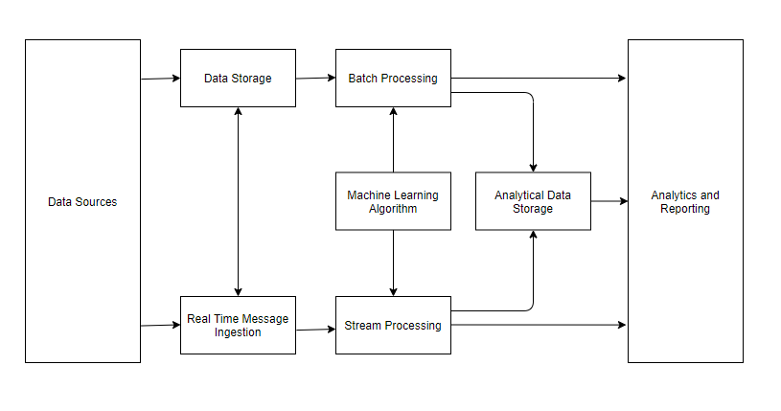

Figure 4.1 OVERVIEW OF ARCHITECTURE

**4.2 USE CASE DIAGRAM**

This diagram shows the user such as actor, editors and the role of developer in this project. This behaviour diagram models the functionality of the system using use cases.

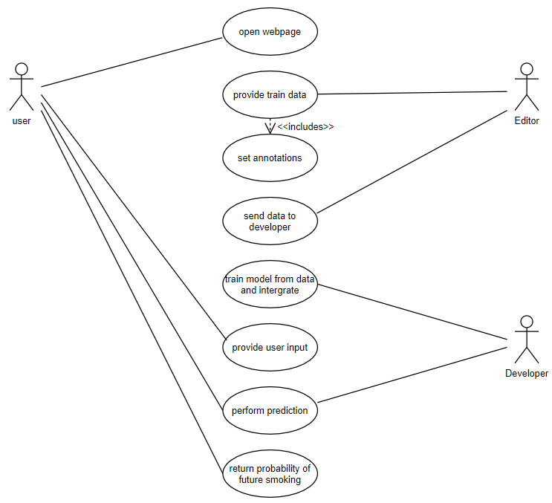

Figure 4.2 USE CASE DIAGRAM

**4.3 CLASS DIAGRAM**

The structure of the application id described in the class diagram by showing the system’s classes, their attributes, operations (or methods), and the relationships among objects. Each class has their attributes and the operations defined with the relationship between the classes.

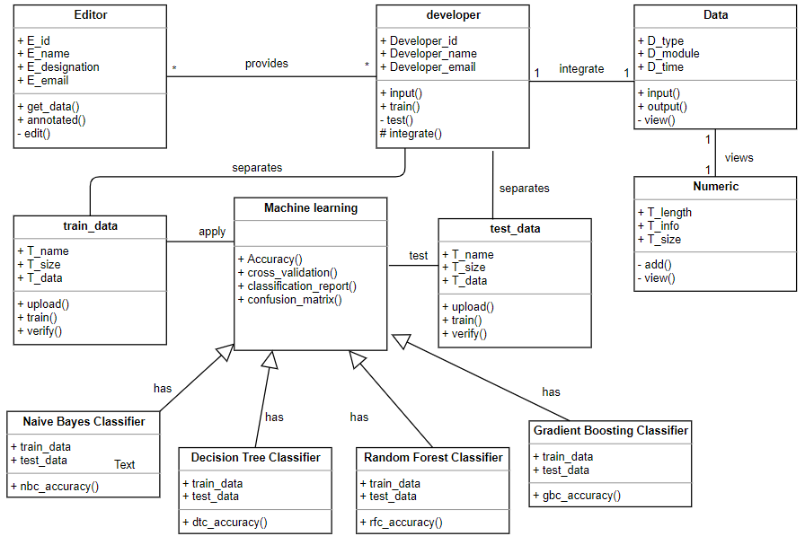

Figure 4.3 CLASS DIAGRAM

**4.4 MODULE DIAGRAM**

**4.4.1 MODULE 1/2/3 – BUSINESS UNDERSTANDING**

This module diagram simply depicts interaction between objects in a sequential order i.e. the order in which these interaction take place. The objects in this module are Developer, server, User and Application.

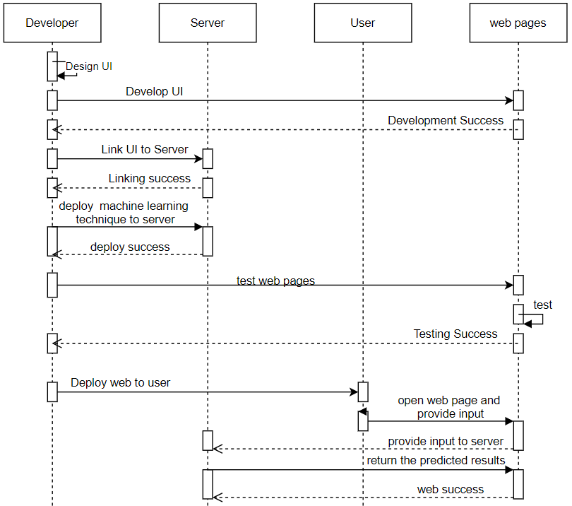

Figure 4.4.1 MODULE 1/2/3 – Sequence Diagram for Business Understanding

**4.4.2 MODULE 4/5 – MODELLING**

This module diagram represents the flow from one activity to another activity. The activity can be described as an operation of the system. Some activities are based on conditions satisfied by the actor/object.

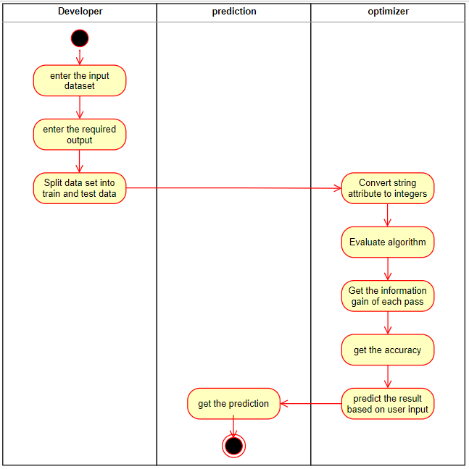

Figure 4.4.3 MODULE 4/5 Activity diagram for Modelling

**4.4.3 MODULE 6 – DEPLOYMENT**

This module diagram simply depicts interaction between objects in a sequential order i.e. the order in which these interactions take place. The objects in this module are User, Web Server, ML model Reasoner.

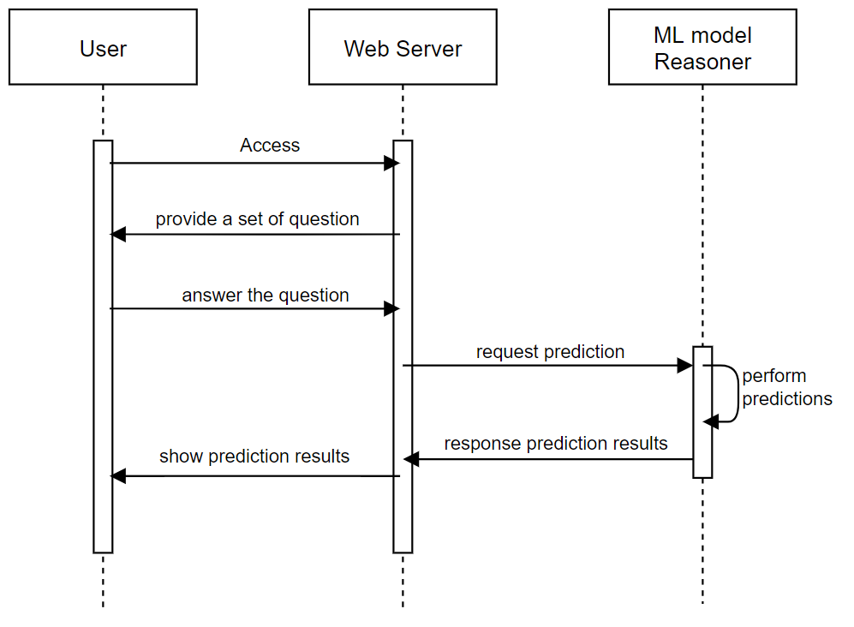

Figure 4.4.3 MODULE 6 – Sequence Diagram for Deployment

**CHAPTER 5**

**IMPLEMENTATION**

**5.1 MODULES**

* Business Understanding
* Data Understanding
* Data preparation
* Modelling
* Evaluation
* Deployment

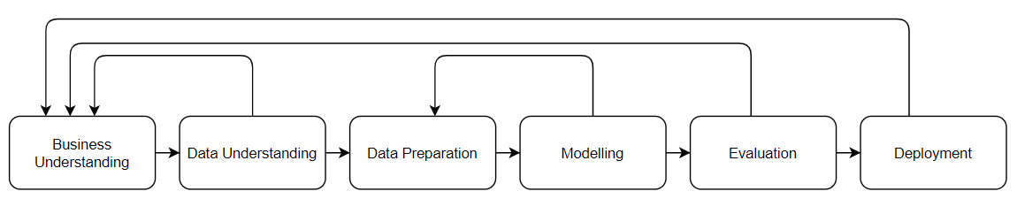

**Figure 5.1 phases of implementation**

**5.1.1 BUSINESS UNDERSTANDING**

In this project, our goal has two folds of objectives.

* The ﬁrst goal is to determine the most accurate machine learning model between Gaussian Naive Bayes, Decision Tree, Random Forest, and Gradient Boosting.
* The second is to construct a public web that will allow adolescents to know whether they will have the intention to smoke or not.

We utilize the data from NYTS for 2018 in order to construct ML models, and the models are analysed to choose the most accurate one in predicting the intention for a non-smoker to smoke cigarettes.

**5.1.2 DATA UNDERSTANDING**

Data Understanding includes ﬁnding an initial data set, familiarizing with the contents in the data set, and making observations from the data set in order to create a hypothesis. The initial data set must be reliable and accurate, which means that it is not outdated and has correlation within itself.

|  |  |  |
| --- | --- | --- |
| Question Number | Question | Answers |
| Q1 | How old are you? | 9, 10, ..., 19 years old |
| Q2 | What is your sex? | Male/Female |
| Q3 | What grade are you in? | 6, 7, …, 12, ungraded or other grade |
| … | … | … |
| Q88 | Because of a physical…making decision? | No/Yes |

**5.1.3 DATA PREPARATION**

* Our original data was taken from the National Youth Tobacco Surveys 2018. This data set was compiled of questions represented as questions Q and answers represented by numbers (e.g., 1, 2, 3, and 4) and words (e.g., Yes and No).
* We ﬁltered every question to prepare for machine learning. For example, any null in the answer meant that the question was not answered. We went through the process of replacing all the nulls with 0’s, which represents the unanswered choices.
* The next process involved classifying related data. When we ﬁrst found the data, it was a set of 20189 rows x 195 columns.
* Our goal is to construct a prediction model construct a public web. In order to achieve this goal, we needed to divide the data into two groups: never smoked cigarette users and ever smoked cigarette users.
* Then, all the rows containing individuals who have ever smoked in their lives were deleted, because we only need to analyse the youths who never smoked cigarettes. The purpose of the ﬁrst split of the cigarette and non-cigarette users is to form a predictive model.
* We extracted our target question and the questions pertaining to it. There are 88 questions within the survey we used, but not every question was related to our prediction.
* After examining all the survey questions, we chose speciﬁc questions to be used, since not all the questions were applicable to our goal and redundancies and indirect correlations were present. Out of 88 questions, 41 questions were used.

**5.1.4 MODELLING**

We used ﬁve ML algorithms to generate each ML model using a training data and evaluated the accuracy for each one of the models. The models include

* Gaussian NB Classiﬁer
* Decision Tree Classiﬁer
* Random Forest Classiﬁer
* Gradient Boosting Classiﬁer

Out of the whole data set, we assigned the training data set, which is 80 percent of the original data, and the test data set, which is 20 percent of the original data. The training data set is used to learn the prediction model while the test data set is used to test the learned model by evaluating the accuracy for each model. After examining the predicted accuracy, we can evaluate the model that showed the highest accuracy.

**NAÏVE BAYES CLASSIFIER**

* Naive Bayes (NB) Classiﬁer is a classiﬁcation method based on probability theory, by which one can classify class labels using inputs. Basically, NB represents a joint distribution for input random variables(X) and a class random variables(Y) on the assumption of conditionally independence of X given Y = c.

$Ρ\left(X,Y=c\right)=Ρ\left(Y=C\right)\prod_{i=1}^{k}{Ρ\left(X_{i} | Y=c\right)}$ (1)

* Where K is the number of input random variables and c denotes a class label in Y.
* It uses continuous inputs under the Gaussian (or Normal) distribution assumption.

$Ρ\left(X,Y=c\right)= Ρ\left(Y=C\right)\prod_{i=1}^{k}{N\left(X_{i} | μ_{i}\text{ ,c},σ_{i}\text{, c}\right)}$ (2)

* Where $μ_{i}$, c and $σ_{i}$, c denote the mean and standard deviation of the input i for the class label c, respectively.

**DECISION TREE CLASSIFIER**

* Decision tree Classiﬁer consists of a tree structure containing a set of hierarchical nodes. The root node and the internal nodes represent features or variables, while the leaf nodes denote values of a target variable. The main challenge of machine learning for decision tree is to construct these nodes and their hierarchy in a decision tree, so that it can effectively classify classes using input data of predictor variables.

$I\left(p,n\right)=-\frac{p}{p+n}\log_{2}\frac{p}{p+n}-\frac{n}{p+n}\log_{2}\frac{n}{p+n}$ (3)

* Where p and n denote the numbers of positive and negative cases, respectively. The expected information E(.) for a parent node A of the target variable can be derived as the weighted average.

$E\left(A\right)$ = $\sum_{i=1}^{v}{\frac{p_{i+ n_{i}}}{p+n}}I\left(p_{i} | n_{i}\right)$ (4)

* Where v denotes the number of the parent node values and I($p_{i}$, $n_{i}$) denotes the expected information for the i-th value of the parent node. The information gain(A) for the node A can be obtained as the following equation.

$gain\left(A\right)=I\left(p,n\right)-E\left(A\right)$ (5)

**RANDOM FOREST CLASSIFIER**

* A set of ML models can often have a better performance than the use of a simple ML model. Such integration of ML models is called an ensemble learning.
* Random Forest Classifier uses the ensemble learning by forming a set of decision trees and resulting in an output which are voted from each decision tree. Random Forest draw random samples from training data and learn a decision tree model from the sample data, so that it can have a set of decision trees (i.e., forest).
* After machine learning, in the prediction (or application) stage, the class voted by the majority of learned decision trees is chosen as the final result. The following shows an equation for such majority voting.

$\hat{y}=mode\left\{a_{1}\left(x\right),a_{2}\left(x\right),…,a_{n}(x)\right\}$ (6)

* Where $a_{i}$ (*x*) is a single decision tree and the function *mode*(.) yields the output as the class label that is the most frequent class among the set of classification results.

**GRADIENT BOOSTING CLASSIFIER**

* Gradient Boosting Classiﬁer uses an ensemble model consisting of a set of simple models.
* By adding such simple models, the result ensemble model can be sequentially improved and ﬁnally ﬁtted to data.
* In other words, after applying a simple model, samples which are classiﬁed by it are reused to another simple model. And then this process is repeated until convergence (or achieving better predictive performance). Gradient Boosting Classiﬁer is a generalized method of boosting by using gradient of a loss function.

**5.1.5 EVALUATION**

Evaluation is reviewing performance (e.g., accuracy) of models and deciding a best model. This is the process where the models are improved based a goal performance. Success criteria can be based on speed of algorithm, memory usage, or prediction accuracy. The sum of correct classiﬁcation divided by the total number of classiﬁcations, can be used.

Since this project uses classiﬁcation, some criteria for classiﬁcation are introduced in the following.

$Accuracy= \frac{The number of correct classification}{The total number of classification}= \frac{\sum_{i=1}^{N}{x_{ij}}}{\sum_{i=1}^{N}{\sum_{j=1}^{N}{x_{ij}}}}$ (7)

Where N denotes the number of class $x_{ij}$ and denotes the total number of the case in which values of i-th prediction and j-th observation are identical. In this study, we used the four – performance metrics Accuracy (Equation1), Precision (Equation2), Recall (Equation 3), and F1-score (Equation 4). These metrics can be easily calculated by using the following four indicators.

* True Positive (TP): The amount of the observed positive values which were correctly predicted.
* False Positive (FP): The amount of the observed positive values which were wrongly predicted.
* False Negative (FN): The amount of the observed negative values which were wrongly predicted.
* True Negative (TN): The amount of the observed negative values which were correctly predicted.

These four indicators can be used to deﬁne the equations of Precision and Recall as shown.

$Precision= \frac{TP}{TP+FP}$ (8)

$Recall= \frac{TP}{TP+FN}$ (9)

Precision is commonly used to measure the inﬂuence of False Positive, while Recall is used to measure the inﬂuence of False Negative. F1-score is deﬁned as the weighted average of Precision and Recall.

$F1-Score=\frac{2 * \left(Precision *Recall\right) }{Precision+Recall}$ (10)

Precision, Recall, and F1-score have a score of one when the prediction is perfect. For the total prediction failure, they yield a score of zero.

**5.1.6 DEPLOYMENT**

Deployment is the process of organizing the information gained, such as the model, so that it is understandable for the model user. This step is carried out by the user rather than the analyst, so it is essential for the user to understand how to use the models. The result of this step is a ﬁnal report.

**CHAPTER 6**

**SYSTEM TESTING**

**6.1 TESTING OBJECTIVES**

The purpose of testing is to discover errors. Testing is the process of trying to discover every conceivable fault or weakness in a work product. It provides a way to check the functionality of components, sub-assemblies and/or a finished product. It is the process of exercising software with the intent of ensuring that the software system meets its requirements and user expectations and does not fail in an unacceptable manner. There are various types of test. Each test type addresses a specific testing requirement.

**6.2 TYPES OF TESTS**

In order to uncover the errors present in different phases we have the concept of levels of testing. The basic levels of testing are

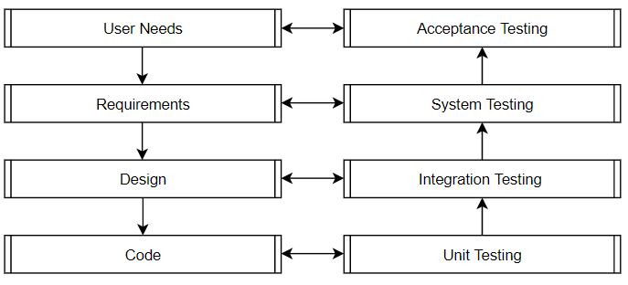

**6.2.1 UNIT TEST CASES**

Unit testing involves the design of test cases that validate that the internal program logic is functioning properly, and that program inputs produce valid outputs. All decision branches and internal code flow should be validated. It is the testing of individual software units of the application. It is done after the completion of an individual unit before integration. This is a structural testing, that relies on knowledge of its construction and is invasive. Unit tests perform basic tests at component level and test a specific business process, application, and/or system configuration. Unit tests ensure that each unique path of a business process performs accurately to the documented specifications and contains clearly defined inputs and expected results.

In this project the unit testing validates the program logic of all modules in range of machine learning and big data.

The testing takes place as:

**Input:** Module select, Text, drop down boxes

**Output:** Adapt user interface based on module select. Show information on getting input required for each operations, to show required output.

**6.2.2 FUNCTIONAL TEST CASE**

Functional tests provide systematic demonstrations that functions tested are available as specified by the business and technical requirements, system documentation, and user manuals.

Functional testing is centred on the following items:

**Valid Input:** Select Text, Image, Data.

**Functions:** Inputs must be processed based on the user requirements and Machine Learning algorithm must be executed.

**Output:** Probability of data is carried out.

**Systems/Procedure:** Health care system or algorithm must be invoked.

In this project Functional testing is applied to the functionality of all modules (input and output of the modules) and hence it is verified.

**Input:** Selection and user inputs

**Output:** Change of user interfaces according to user problems, conversion of sender input to recipient’s mode, translation of input, recognition, detection.

**6.2.3 INTEGRATION TEST CASES**

Integration tests are designed to test integrated software and hardware components to determine if they actually run as one program. Testing is event driven and is more concerned with the basic outcome of screens or fields. Integration tests demonstrate that although the components were individually satisfaction, as shown by successfully unit testing. The combination of components is correct and consistent. Integration testing is specifically aimed at exposing the problems that arise from the combination of components.

In this project the integration takes place in hardware components and software testing is verified.

**Input:** Proper functional testing of the system (Device), processing speed, Memory, Data usage.

**Output:** System working well, instantaneous output, less memory consumption and Data usage.

**Front End:** HTML, CSS, JavaScript.

**Back End:** Machine Learning.

**6.2.4 SYSTEM TEST CASES**

System testing manages that the entire integrated software system meets requirements. It tests a configuration to ensure known and predictable results. An example of system testing is the configuration oriented system integration test. System testing is based on process descriptions and flows, emphasizing pre-driven process, identity errors, links, and integration points.

In this project, the system testing is verified.

* Coding.
* Machine learning Algorithms.
* Debugging coding errors.

**6.2.5 ACCEPTANCE TEST CASES**

User acceptance testing is a critical phase of any project and requires significant participation by the end user. It also ensures that the system meets the functional requirements.

The main types of software testing are

**Components:** Hardware is tested.

**Interface:** Functionality of the algorithm is tested.

**System:** step by step procedure of working is tested.

**Acceptance:** Input is accepted as per the functionality.

**Release:** Output is produced according to the input given.

In this project the acceptance testing is verified.

**6.2.6 WHITE BOX TEST CASES**

White box testing is a testing in which the software tester has knowledge of the inner workings, structure and language of the software, or at least its purpose. It is used to test areas that cannot be reached from a black box level.

In this project, white box testing takes place as follows

* Testing of Back end through the database provided.
* Testing of Front end through the input provided and relevant output produced for the inputs through the coding logic and verified.

**6.2.7 BLACK BOX TEST CASES**

Black Box Testing is testing the software without any knowledge of the inner workings, structure or language of the module being tested. Black box tests, must be written from a definitive source document, like specification or requirements documents, such as specification or requirements document. It is attesting in which the software under test is treated, as a black box. The test provides inputs and responds to outputs without considering how the software works.

In this project Black box testing is the final step which is the documentation process with the theoretical information and does not involve the practical step by step procedure, hence the testing is performed and verified.

**CHAPTER 7**

**CONCLUSION AND FUTURE ENHANCEMENT**

**7.1 CONCLUSION**

cigarette use has increased among adolescents. This is a worldwide problem, because it has been stated in many researches mentioned in the introduction that e-cigarette use can cause future use of cigarettes. Since e-cigarette is a recent rising issue, there is little research done on this topic, compared to smoking cigarettes. Even among the researches done, there is a lack of researches implementing prediction models, which are more practical in preventing adolescents from using cigarettes. Thus, we researched using the 2018 NYTS data and developed multiple prediction models to predict an adolescent’s intention to smoke cigarette. The most accurate prediction model was Gradient Boosting Classiﬁer with an overall accuracy of 93%. This model was applied in the website we designed to allow the public to input their information in respect to tobacco products, including e-cigarette, cigarette, and cigar. With this information, the algorithm can predict the respondee’s probability of future of smoking. This will help the public become more aware about certain factors in their lives and be attentive about their drug use or how their environment can affect their intention to smoke cigarettes.

**7.2 FUTURE ENHANCEMENT**

This project can be further improved by including a wider range of ages, since our project is mainly focused on adolescents rather than adults. In order to improve the accuracy of the prediction model, it is essential to increase the amount of data or choose better, more ﬁtting, variables.

**APPENDICES**

**APPENDIX 1**

**SAMPLE CODING**

**NAÏVE BAYES CLASSIFIER:**

from sklearn.preprocessing import MinMaxScaler

from sklearn.naive_bayes import GaussianNB

from sklearn.externals import joblib

import numpy as np

import pandas as pd

import pickle

import os

from sklearn.metrics import accuracy_score

from sklearn.model_selection import train_test_split,KFold

#root = os.path.dirname(__file__)

#path_df = os.path.join(root, 'recons_dataset/combined_dataset.csv')

data = pd.read_csv('dataset7.csv')

scaler = MinMaxScaler()

train, test = train_test_split(data, test_size=0.10)

X_train = train.drop('Q7', axis=1)

Y_train = train['Q7']

X_test = test.drop('Q7', axis=1)

Y_test = test['Q7']

# We don't scale targets: Y_test, Y_train as SVC returns the class labels not probability values

X_train = scaler.fit_transform(X_train)

X_test = scaler.fit_transform(X_test)

clf1 = GaussianNB()

# Training the classifier

clf1.fit(X_train, Y_train)

# Testing model accuracy. Average is taken as test set is very small hence accuracy varies a lot everytime the model is trained

acc = 0

acc_binary = 0

for i in range(0, 20):

Y_hat = clf1.predict(X_test)

Y_hat_bin = Y_hat>0

Y_test_bin = Y_test>0

acc = acc + accuracy_score(Y_hat, Y_test)

acc_binary = acc_binary + accuracy_score(Y_hat_bin, Y_test_bin)

print("Average test Accuracy:{}".format(acc/20))

print("Average binary accuracy:{}".format(acc_binary/20))

# Saving the trained model for inference

#model_path = os.path.join(root, 'models/rfc.sav')

#joblib.dump(clf, model_path)

# Saving the scaler object

#scaler_path = os.path.join(root, 'models/scaler.pkl')

#with open(scaler_path, 'wb') as scaler_file:

# pickle.dump(scaler, scaler_file)

x = np.array([5,1,2,2,2,2,1,5,2,1,3,1,1,1,2,1,1,1,1,4,3,5,1,3,4,5,2,2,3,1,4,

3,3,2,4,3,1,1,1,1,1,2]).reshape(1, -1)

x = scaler.transform(x)

y = clf1.predict(x)

predictions = clf1.predict_proba(x)

print(predictions)

print(y)

**DECISION TREE CLASSIFIER:**

from sklearn.preprocessing import MinMaxScaler

from sklearn.externals import joblib

import numpy as np

import pandas as pd

import pickle

import os

from sklearn.metrics import accuracy_score

from sklearn.model_selection import train_test_split

from sklearn import tree

#root = os.path.dirname(__file__)

#path_df = os.path.join(root, 'recons_dataset/combined_dataset.csv')

data = pd.read_csv('dataset1.csv')

scaler = MinMaxScaler()

train, test = train_test_split(data, test_size=0.10)

X_train = train.drop('Q7', axis=1)

Y_train = train['Q7']

X_test = test.drop('Q7', axis=1)

Y_test = test['Q7']

# We don't scale targets: Y_test, Y_train as SVC returns the class labels not probability values

X_train = scaler.fit_transform(X_train)

X_test = scaler.fit_transform(X_test)

clf1 = tree.DecisionTreeClassifier()

# Training the classifier

clf1.fit(X_train, Y_train)

# Testing model accuracy. Average is taken as test set is very small hence accuracy varies a lot everytime the model is trained

acc = 0

acc_binary = 0

for i in range(0, 20):

Y_hat = clf1.predict(X_test)

Y_hat_bin = Y_hat>0

Y_test_bin = Y_test>0

acc = acc + accuracy_score(Y_hat, Y_test)

acc_binary = acc_binary + accuracy_score(Y_hat_bin, Y_test_bin)

print("Average test Accuracy:{}".format(acc/20))

print("Average binary accuracy:{}".format(acc_binary/20))

# Saving the trained model for inference

#model_path = os.path.join(root, 'models/rfc.sav')

#joblib.dump(clf, model_path)

# Saving the scaler object

#scaler_path = os.path.join(root, 'models/scaler.pkl')

#with open(scaler_path, 'wb') as scaler_file:

# pickle.dump(scaler, scaler_file)

x = np.array([5,1,2,2,2,2,1,5,2,1,3,1,1,1,2,1,1,1,1,4,3,5,1,3,4,5,2,2,3,1,4,3,3,2,4,3,1,1,1,1,1,2]).reshape(1, -1)

x = scaler.transform(x)

y = clf1.predict(x)

predictions = clf1.predict_proba(x)

print(predictions)

print(y)

**RANDOM FOREST CLASSIFIER:**

from sklearn.preprocessing import MinMaxScaler

from sklearn.ensemble import RandomForestClassifier

from sklearn.externals import joblib

import numpy as np

import pandas as pd

import pickle

import os

from sklearn.metrics import accuracy_score

from sklearn.model_selection import train_test_split

root = os.path.dirname(__file__)

path_df = os.path.join(root, 'recons_dataset/combined_dataset.csv')

data = pd.read_csv(path_df)

scaler = MinMaxScaler()

train, test = train_test_split(data, test_size=0.25)

X_train = train.drop('num', axis=1)

Y_train = train['num']

X_test = test.drop('num', axis=1)

Y_test = test['num']

# We don't scale targets: Y_test, Y_train as SVC returns the class labels not probability values

X_train = scaler.fit_transform(X_train)

X_test = scaler.fit_transform(X_test)

clf = RandomForestClassifier()

# Training the classifier

clf.fit(X_train, Y_train)

# Testing model accuracy. Average is taken as test set is very small hence accuracy varies a lot everytime the model is trained

acc = 0

acc_binary = 0

for i in range(0, 20):

Y_hat = clf.predict(X_test)

Y_hat_bin = Y_hat>0

Y_test_bin = Y_test>0

acc = acc + accuracy_score(Y_hat, Y_test)

acc_binary = acc_binary +accuracy_score(Y_hat_bin, Y_test_bin)

print("Average test Accuracy:{}".format(acc/20))

print("Average binary accuracy:{}".format(acc_binary/20))

# Saving the trained model for inference

model_path = os.path.join(root, 'models/rfc.sav')

joblib.dump(clf, model_path)

# Saving the scaler object

scaler_path = os.path.join(root, 'models/scaler.pkl')

with open(scaler_path, 'wb') as scaler_file:

pickle.dump(scaler, scaler_file)

**GRADIENT BOOSTING CLASSIFIER**

from sklearn.preprocessing import MinMaxScaler

from sklearn.externals import joblib

from sklearn.ensemble import GradientBoostingClassifier

import numpy as np

import pandas as pd

import pickle

import os

from sklearn.metrics import accuracy_score

from sklearn.model_selection import train_test_split

root = os.path.dirname(__file__)

path_df = os.path.join(root, 'recons_dataset/dataset1.csv')

data = pd.read_csv(path_df)

scaler = MinMaxScaler()

train, test = train_test_split(data, test_size=0.10)

X_train = train.drop('Q15', axis=1)

Y_train = train['Q15']

X_test = test.drop('Q15', axis=1)

Y_test = test['Q15']

# We don't scale targets: Y_test, Y_train as SVC returns the class labels not probability values

X_train = scaler.fit_transform(X_train)

X_test = scaler.fit_transform(X_test)

clf1 = GradientBoostingClassifier()

clf1.fit(X_train, Y_train)

# Testing model accuracy. Average is taken as test set is very small hence accuracy varies a lot everytime the model is trained

acc = 0

acc_binary = 0

for i in range(0, 200):

Y_hat = clf1.predict(X_test)

Y_hat_bin = Y_hat>0

Y_test_bin = Y_test>0

acc = acc + accuracy_score(Y_hat, Y_test)

acc_binary = acc_binary + accuracy_score(Y_hat_bin, Y_test_bin)

print("Average test Accuracy:{}".format(acc/200))

print("Average binary accuracy:{}".format(acc_binary/200))

# Saving the trained model for inference

model_path = os.path.join(root, 'models/rfc1.sav')

joblib.dump(clf1, model_path)

# Saving the scaler object

scaler_path = os.path.join(root, 'models/scaler1.pkl')

with open(scaler_path, 'wb') as scaler_file:

pickle.dump(scaler, scaler_file)

**APPENDIX 2**

**SCREEN SHOTS**

**MODULE-1: BUSINESS UNDERSTANDING AND DATA UNDERSTANDING**

* Business Understanding is introducing the objectives of the project and understanding what the goals will be. Knowing the goals and the objectives, a data mining problem is formed and a plan to achieve these goals is made.
* Data Understanding includes ﬁnding an initial data set, familiarizing with the contents in the data set, and making observations from the data set in order to create a hypothesis. The initial data set must be reliable and accurate, which means that it is not outdated and has correlation within itself.

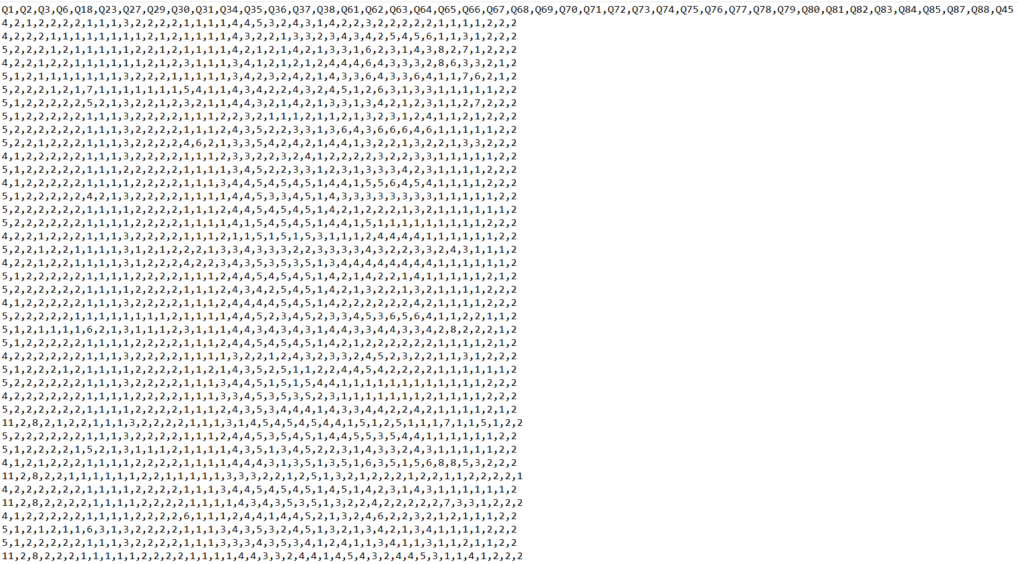

**MODULE-2: DATA PREPARATION**

Data Preparation is the process of converting the initial, or raw, data set into the ﬁnal data set. This step could alter the data to become more applicable to achieve the goal.

Input data sets are correlated with the final output using the mutual information classifier algorithm.

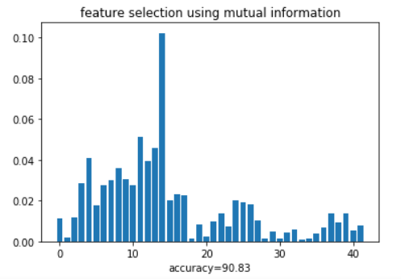

**MODULE-3 MODELLING AND EVALUATION PHASE**

* In Modeling, artiﬁcial intelligence models are created using various machine learning algorithms. The data set prepared from the data preparation step are applied to this modeling step.
* Evaluation is reviewing performance (e.g., accuracy) of models and deciding a best model. This is the process where the models are improved based a goal performance. Success criteria can be based on speed of algorithm, memory usage, or prediction accuracy.

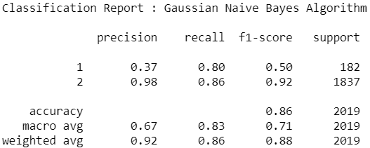

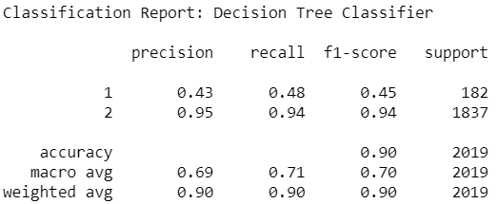

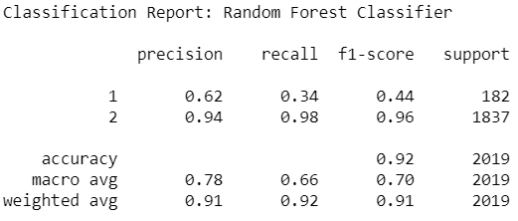

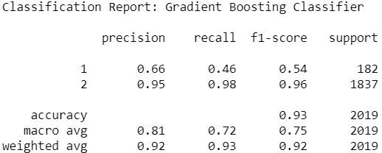**­­­­**

**CONFUSION MATRIX**

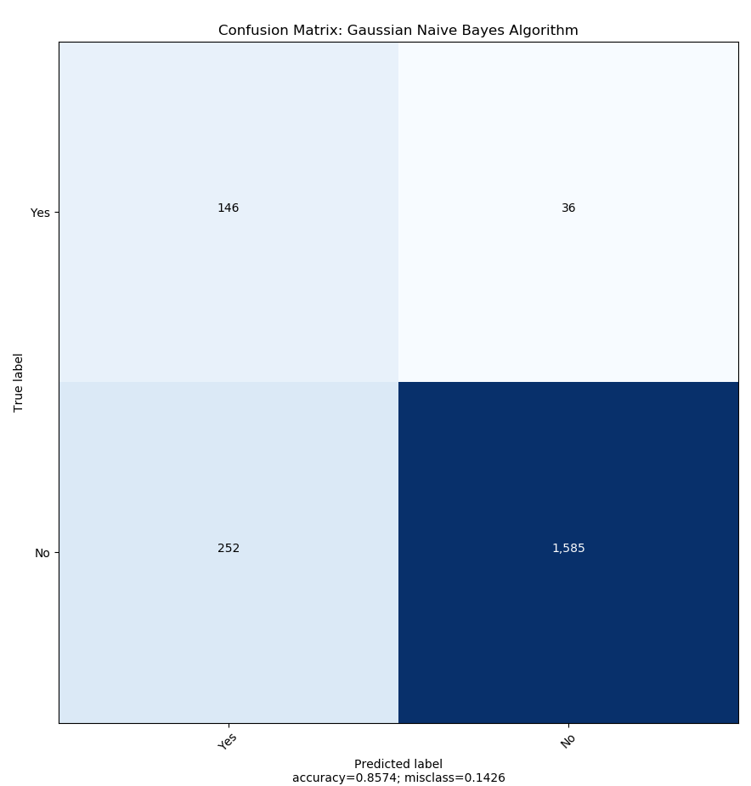

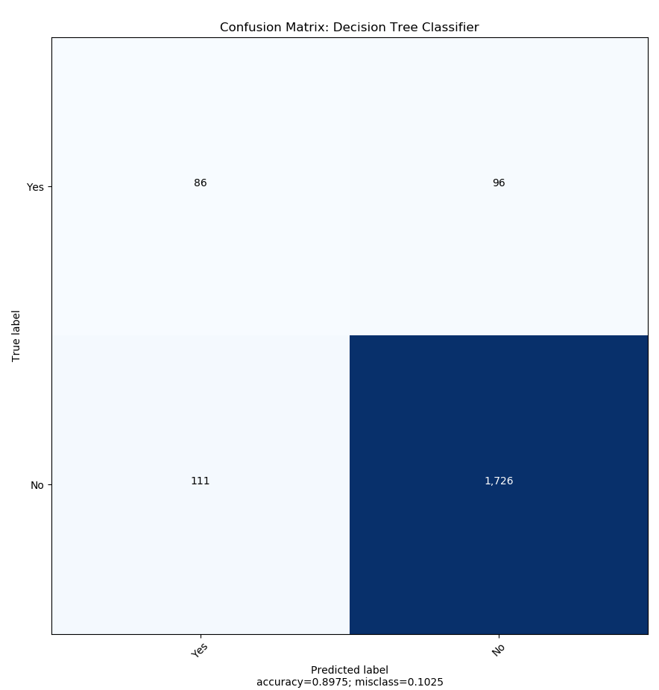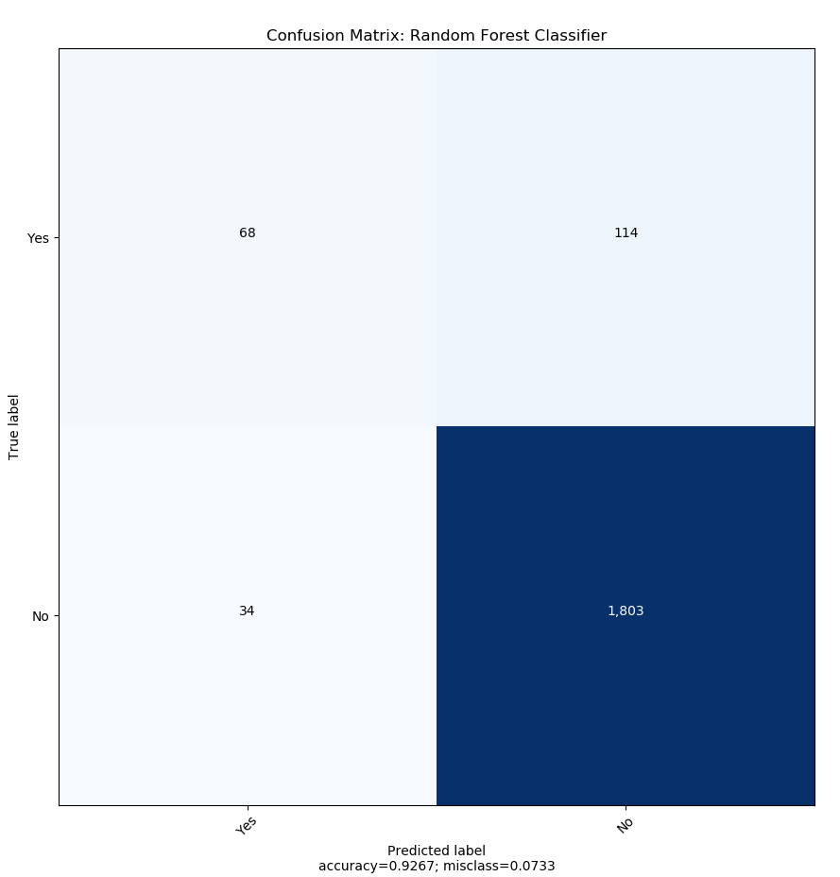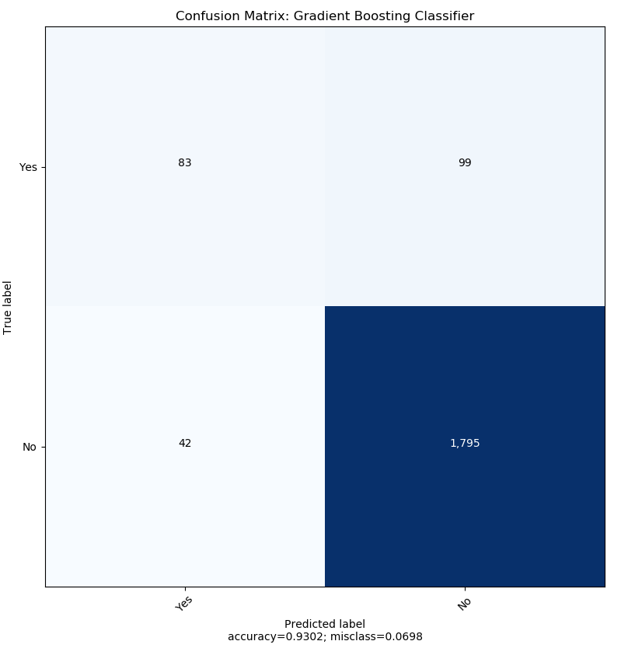

**MODULE-4: DEPLOYMENT**

Deployment is the process of organizing the information gained, such as the model, so that it is understandable for the model user. This step is carried out by the user rather than the analyst, so it is essential for the user to understand how to use the models.

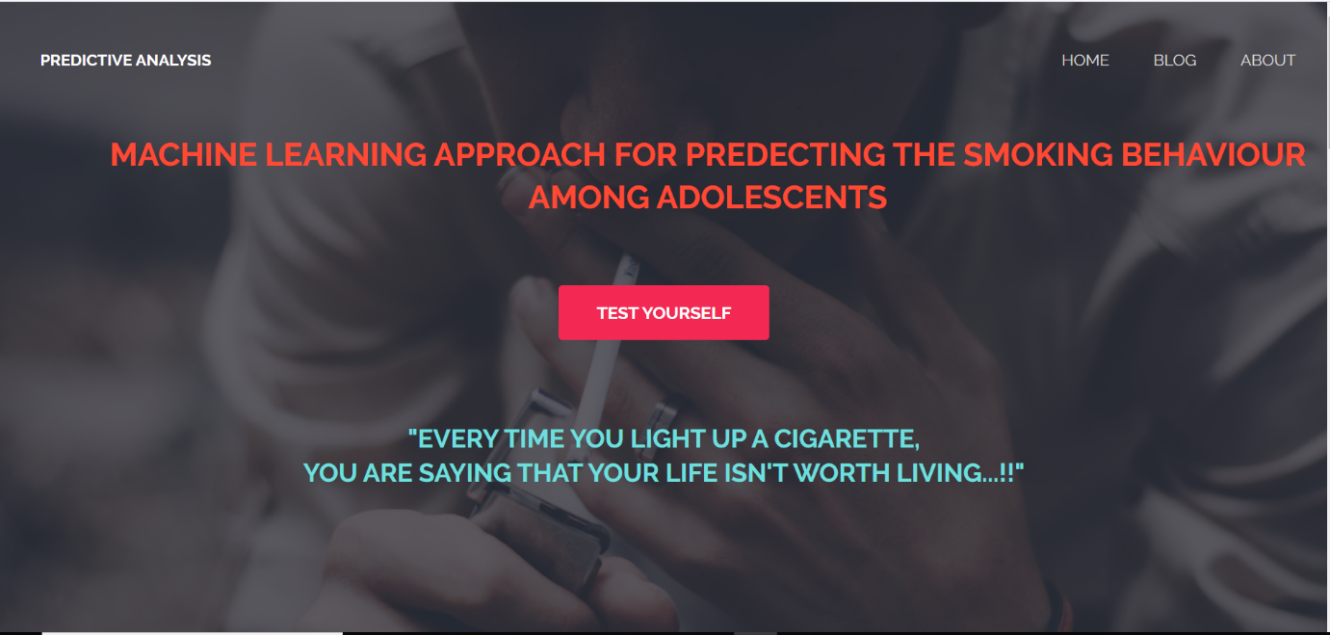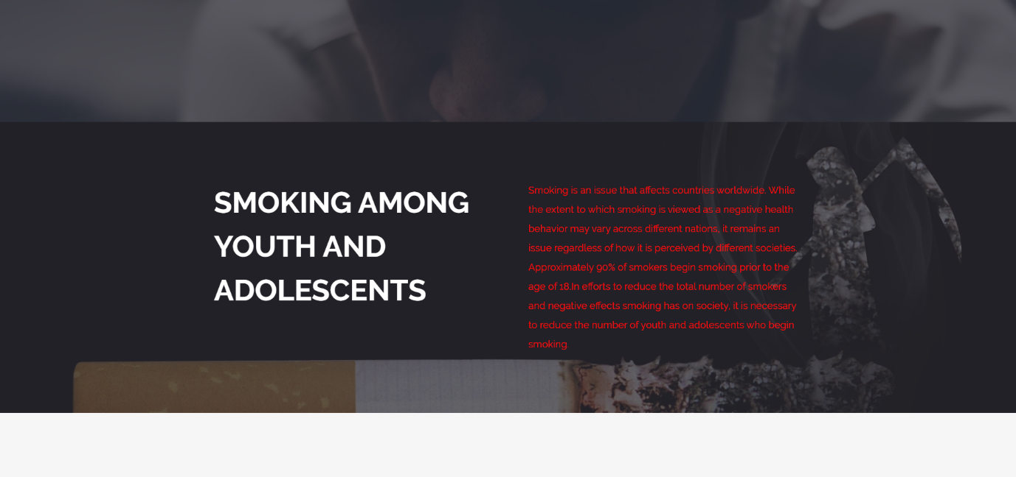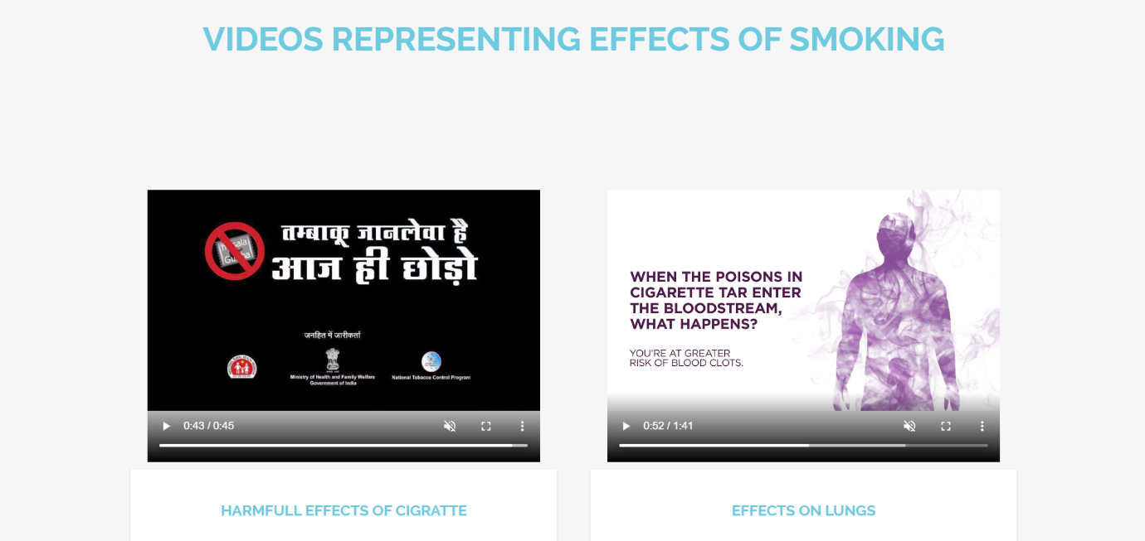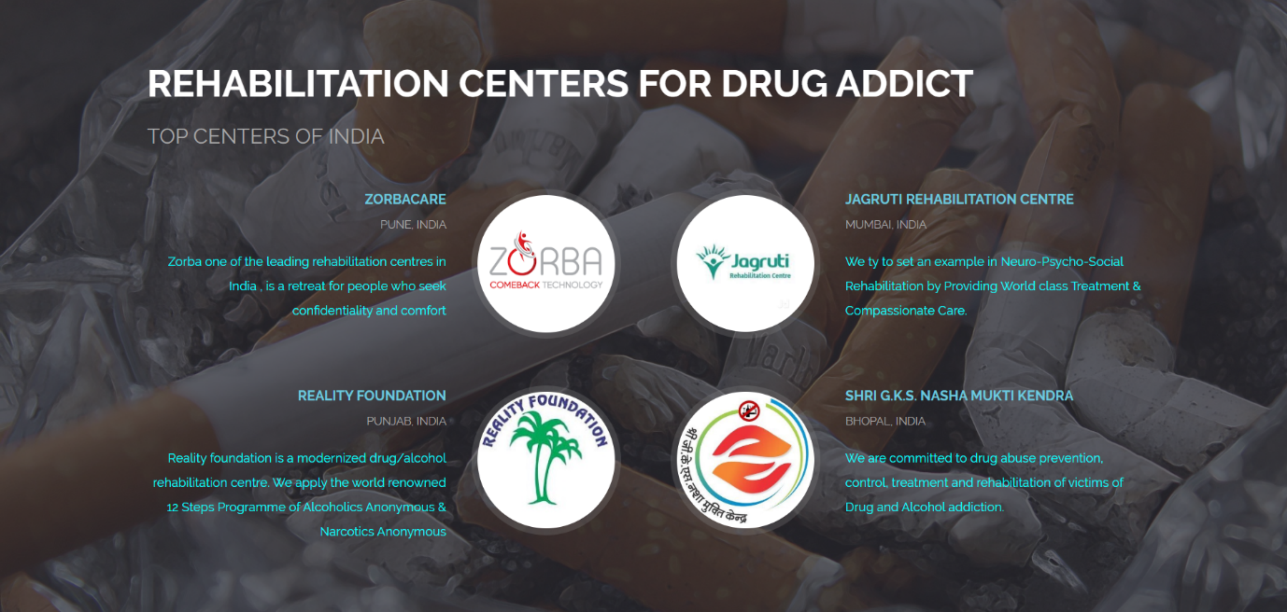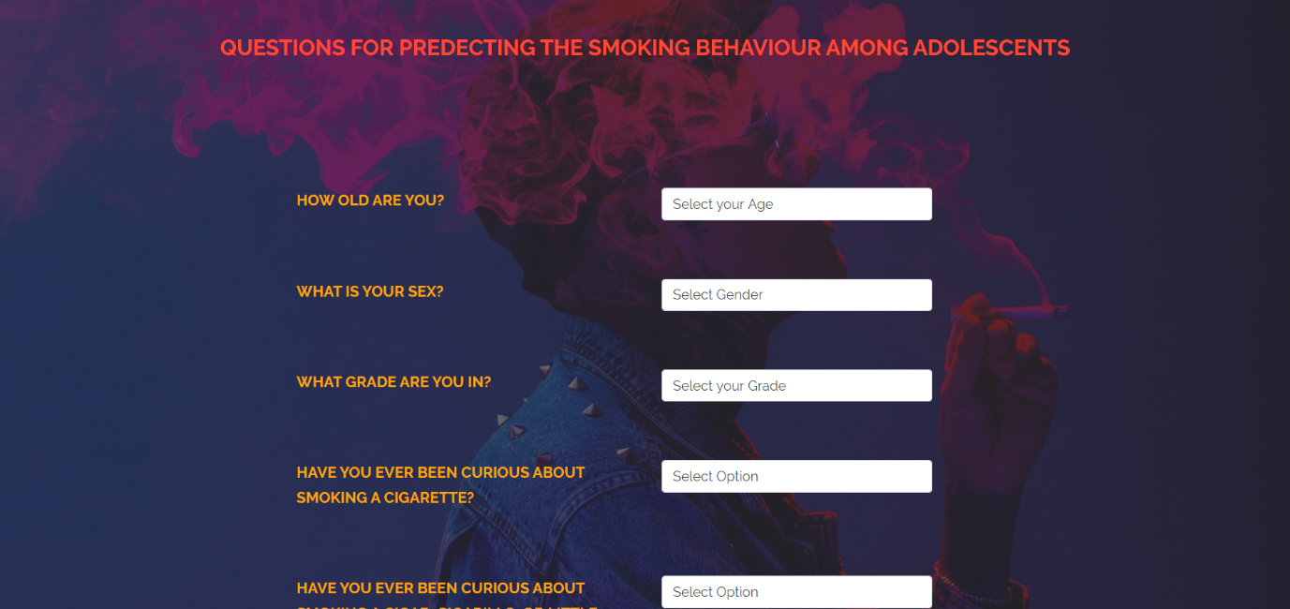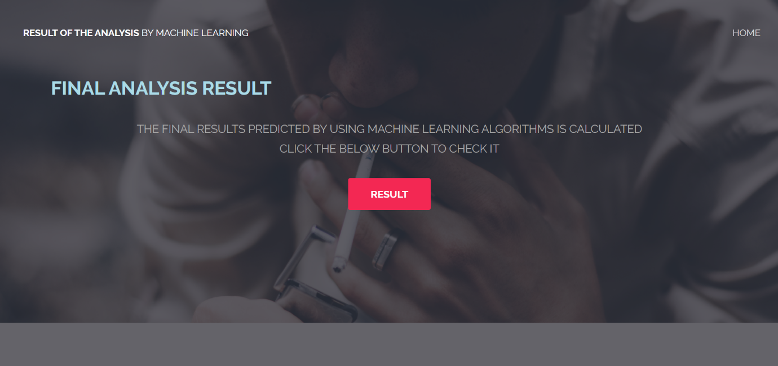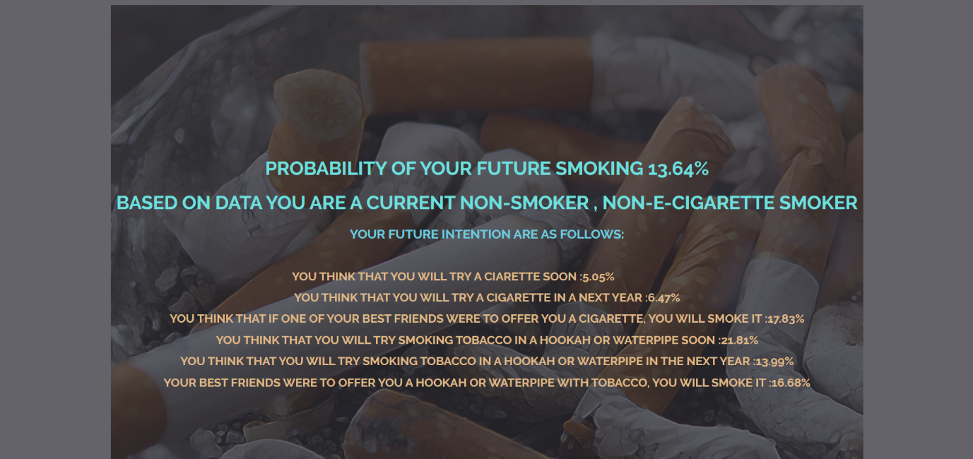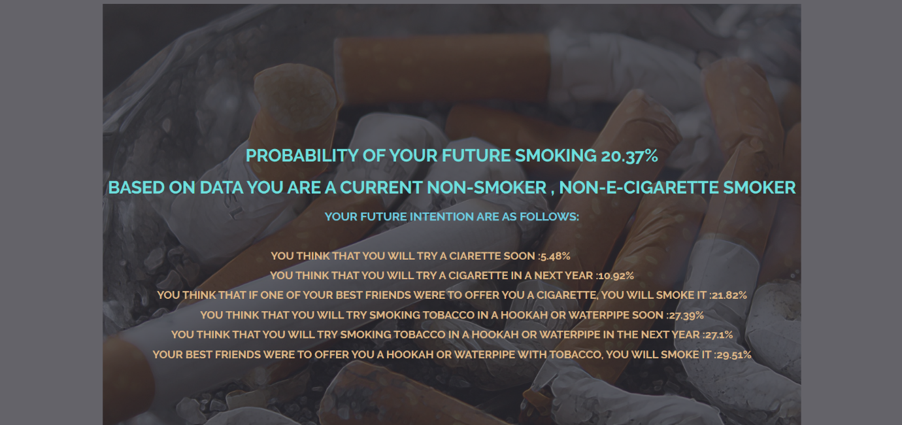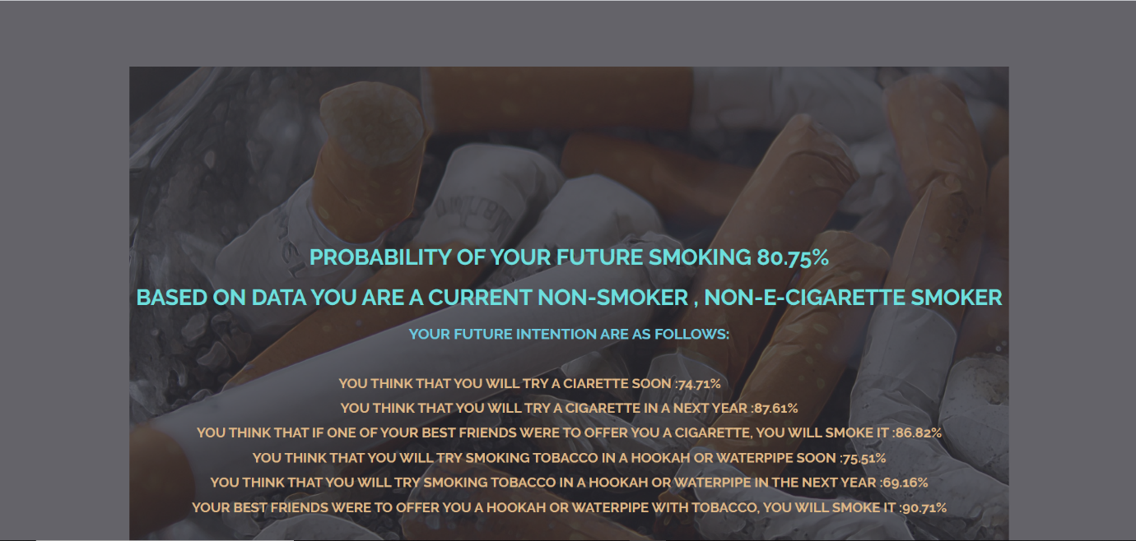

**REFERENCES**

1. Abdullah H. Alsharif, Nada Philip. (2016) ‘Data mining technique for the Enhanced smoking cessation management system (smoke mind)’ International Conference on Big Data.
2. Chen ke, GAO Ying. (2018) ‘Smoking Probability and Cigarettes Consumption of Chinese People’ International Journal of Machine Learning and Computing.
3. Khishigsuren Davagdorj, Keun Ho Ryu. (2019) ‘A Machine Learning Approach for Predicting Success in Smoking Cessation Intervention’ International Journal of Machine Learning and Computing.
4. Shilpa Balan, Nishant Shristiraj, Vrunda Shah and Anusha Manjappa. (2017) ‘Big Data Analysis of Youth Tobacco Smoking Trends in the US’ International Conference on Big Data.
5. Yupu Zhang, Jinhai Liu, Zhihang Zhang, Junnan Huang. (2019) ‘Prediction of Daily Smoking Behavior Based on Decision Tree Machine Learning Algorithm’ International Conference on Big Data.
6. **Website:** machinelearningmastery.com/gentle-introduction-gradient-boosting-algorithm-machine-learning
7. **Website:** towardsdatascience.com/naive-bayes-classifier-81d512f50a7c
8. National Youth Tobacco Survey(NYTS). https://www.cdc.gov/tobacco/data_statistics/surveys/nyts/index.htm. Accessed: 2019-04-20.
9. National Youth Tobacco Survey. https://www.healthypeople.gov/2020/data-source/national-youth-tobacco-survey. Accessed: 2019-08-10.